1. Lambda Expressions
Benefits of lambda
- To enable functional programming in java
- To write more readable and maintainable and more concise code
- To use APIs very easily and efficiently
- To enable parallel processing

What is lambda expression?
- It’s an anonymous function (a function not having any name)
- not having name
- not having any modifiers
- not having any return type
Example:
Normal Method | Equivalent Lambda Expression | Optimal or Simplified lambda expression
Public void m1 (){  Sop(“hello”);  } | () -> { sop(“hello”);}  Note: If there is only one statement in the body, then we can remove the braces also which is given in Optimal expression | () -> sop(“hello”);
Public void add (int a,int b){  Sop(a+b);  } | (int a, int b) -> { sop(a+b);}  Note: based on the context, sometimes the compiler can able to guess the types automatically which is called as Type Inference. Then we can remove the argument types also. | (a,b) -> sop(a+b);
Public int getLength (String s){  return s.length();  } | (String s) -> { return s.length();} | (s) -> return s.length();  (s) -> s.length();  More Simplified one:  S -> s.length();

Properties of lambda expression:
- A lambda expression can take any no of arguments.
Ex: () -> sop("hello');
s -> s.length();
(a,b) -> sop(a+b);

- If multiple parameters present, then these parameters are separated by comma.
Ex: (a,b) -> sop(a+b);
- If only one parameter available, then parenthesis are optional.
(s) -> s.length(); | s -> s.length();

- If the compiler can guess the type based on the context (Type Inference), and then removes the parameter types also.
(String s) -> return s.length(); | (s) -> return s.length();

- If the body contains only one statement, then remove curly braces.
(String s) -> { return s.length();} | (String s) -> return s.length();

- If the expressions return something, the compiler can guess automatically, and then remove the return also.
(s) -> return s.length(); | (s) -> s.length();

- Similiar to method body, lambda expression can contain any number of statements. If multiple statements are there, we should enclose within curly braces.
Ex: () –> {
St1,
St2...
}

Functional interface:
An interface which contains only one abstract method.
Ex:
- Runnable Interface contains run()
- Callable Interface contains call()
- ActionListener Interface contains actionPerformed()
- Comparable Interface contains compareTo()
So on...
- Restriction is applicable for having only one abstract method and it can have any no of default and static methods.

Functional interface example:
Interface intf{
Public void m1(); // abstract method
Default void m2(){}
public static void m3(){}
}

Need of Functional interface:
Used to invoke or call lambda expression (anonymous fn).

@FuntionalInterface – annotation used to say explicitly, the interface should contains only one abstract method. If the interface contains more than one abstract method, then it throws compile time exception for below: unexpected @FunctionalInterface annotation, multiple non overriding abstract methods present in interface intf
@FunctionalInterface
Interface intf{
Public void m1(); // abstract method
Public void m2(); // abstract method
Default void m3(){}
public static void m4(){}
}

Functional interface wrt Inheritance
Case1:
If an interface extends functional interface and child interface doesnt contain any abstract method, then child interface is always functional interface.
@FunctionalInterface
Interface P{
Public void m1()
}
@FunctionalInterface
Interface C extends P{
}
Case 2:
In the child interface, we can define exactly same parent interface abstract method, then the child interface is functional interface cause it is overriding the parent abstract method.
@FunctionalInterface
Interface P{
Public void m1()
}
@FunctionalInterface
Interface C extends P{
Public void m1()
}
Case 3:
In the below child interface, we cannot define any new abstract method, otherwise it throws compile exception.
@FunctionalInterface
Interface P{
Public void m1()
}
@FunctionalInterface
Interface C extends P{
Public void m2()
}

Case 4:
In the below child interface, it contains 2 abstract methods in which one is derived from parent. Eventhough it contains 2 abstract methods, it is valid because it is not annoted as @FunctionalInterface. So it will not throw exception. In this case, the child interface is a normal interface cause it is having 2 abstract mehtods.

@FunctionalInterface
Interface P{
Public void m1()
}
Interface C extends P{
Public void m2()
}

3. Invoking Lambda expression by using functional interface
Example1:
Without lambda Expression:
interface TestInterface{
public void m1();
}

class Test implements TestInterface{
@Override
public void m1() {
System.out.println("m1 method implementation");
}
}

public class LambdaDemo {
public static void main(String[] args) {
TestInterface i=new Test();
i.m1();
}
}

With Lambda Expression:
interface TestInterface{
public void m1();
}

public class LambdaDemo {
public static void main(String[] args) {
TestInterface i = ()->System.out.println("m1 method implementation");
i.m1();
}
}
By using functional interface reference, we are calling m1().
Funtional Interface is the type for the lambda expression.
Also with lambda expression, we don’t need to create a separate class to implement the functional intereface. Instead we can impletent or define the abstract method like below and hold it with functional interface type.
TestInterface i = ()->System.out.println("m1 method implementation");

Example2:
Without lambda:
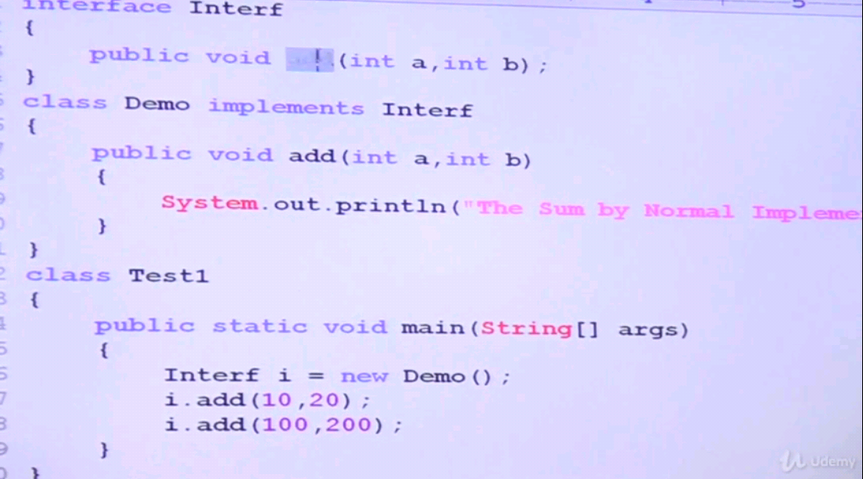
With Lambda:
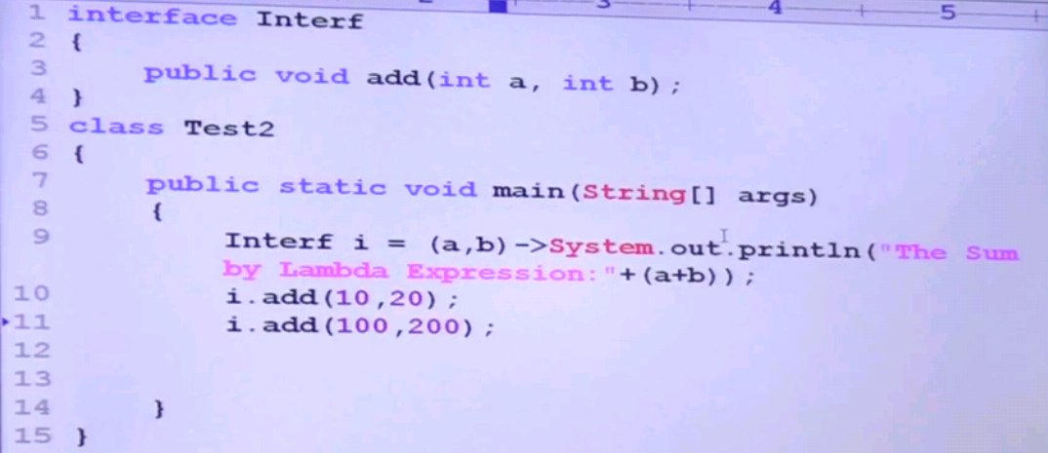
In above lambda, there is no type mentioned for a and b parameters. Eventhough, the compiler can find out the parameter types. This lambda expression is represented by a interface called Interf. So the compiler get the parameter details from the abstract method of your functional interface.

Example3:
Without lambda:
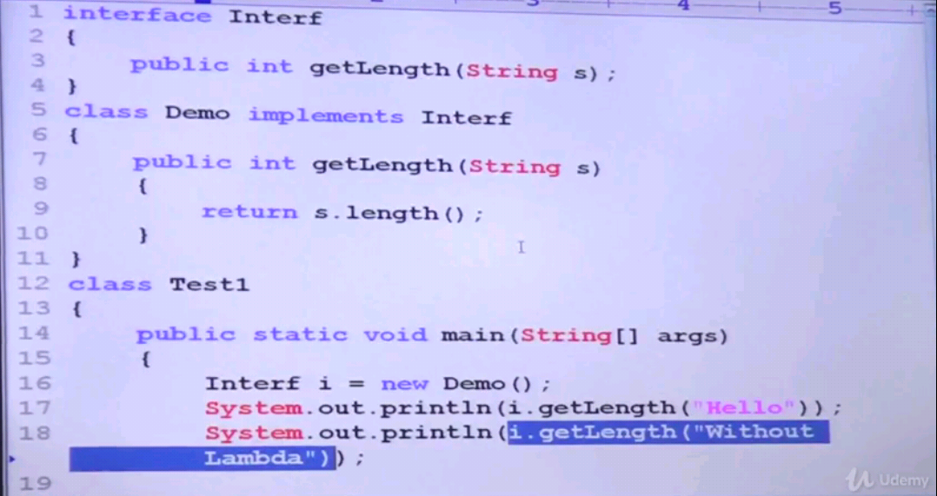
With lambda:
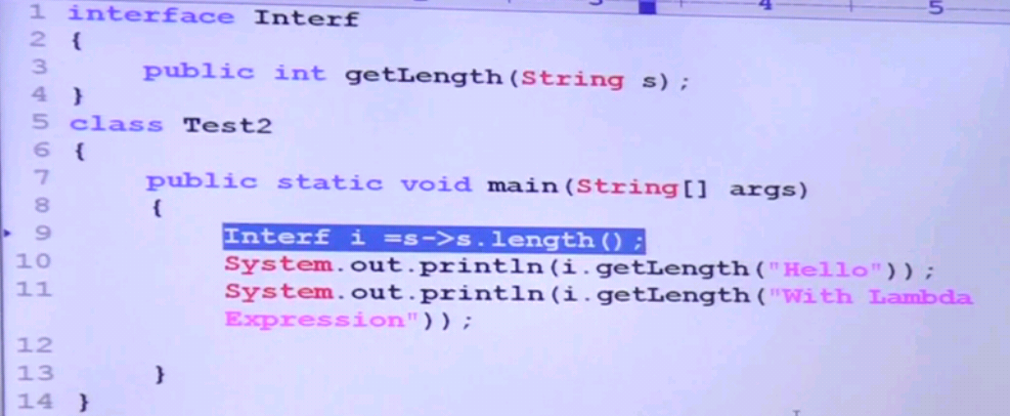
Example 4:
Without lambda:
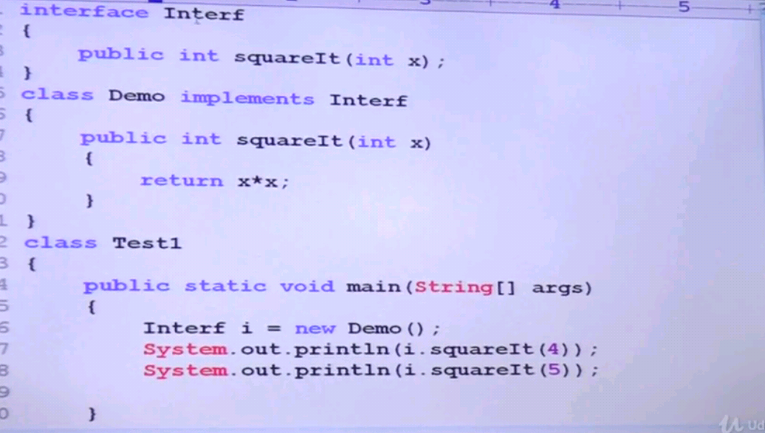
With lambda:
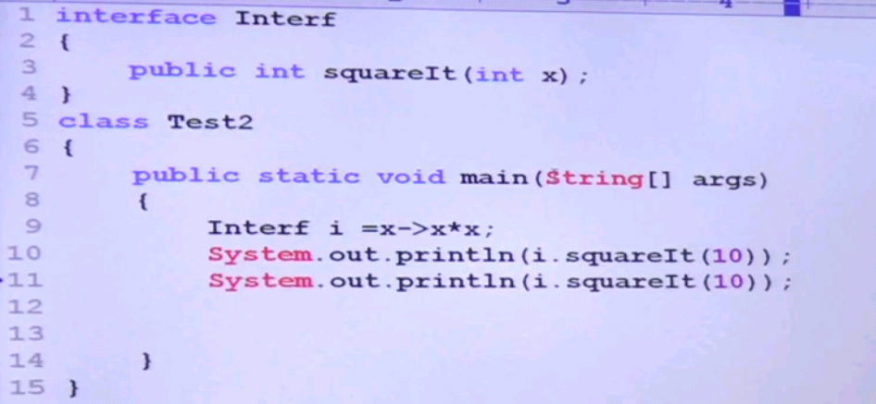

Example 5 using Runnable interface:
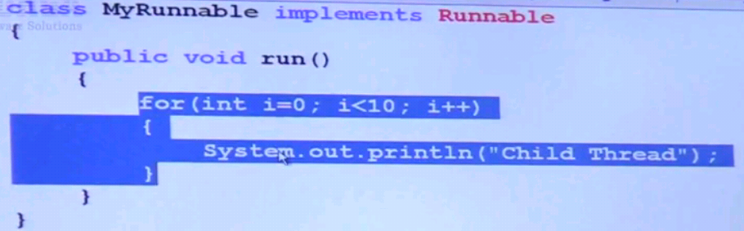
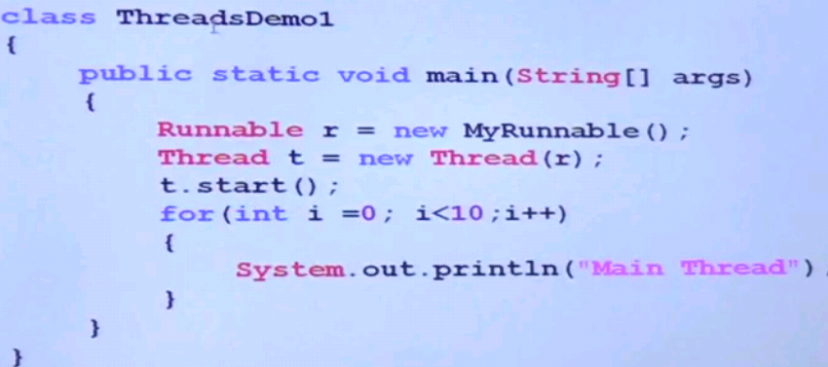
With lambda:
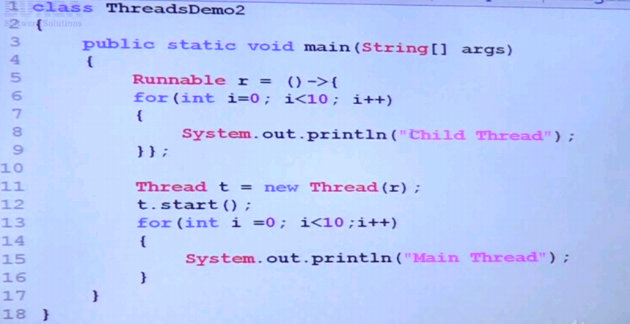
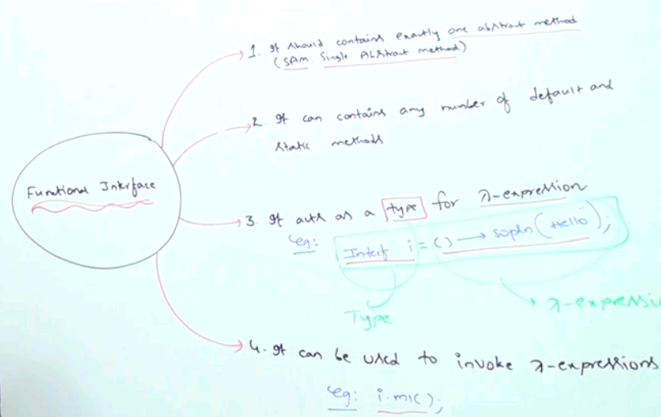

Why functional interface should contain only one abstract method?
In below program, functional interface contains one abstract method m1(). So the lambda expression is mapped to the abstract method m1() of functional interface by the compiler.
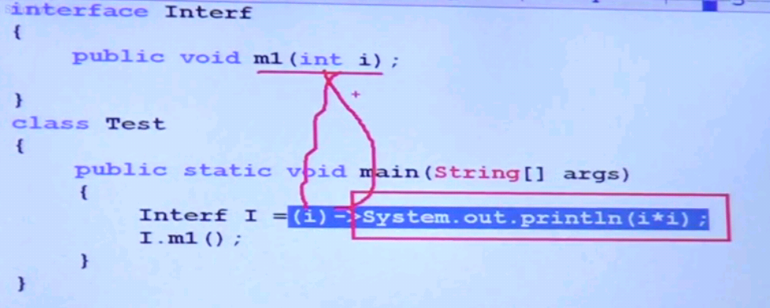
In below program, the interface contains 2 abstract methods and it is not functional interface. The compiler cannot able to map the lambda expression to the abstract method of the interface. There is a conflict arise to which abstract method to map and it throws below CE.
- That’s why the functional interface should contain only one abstract method
